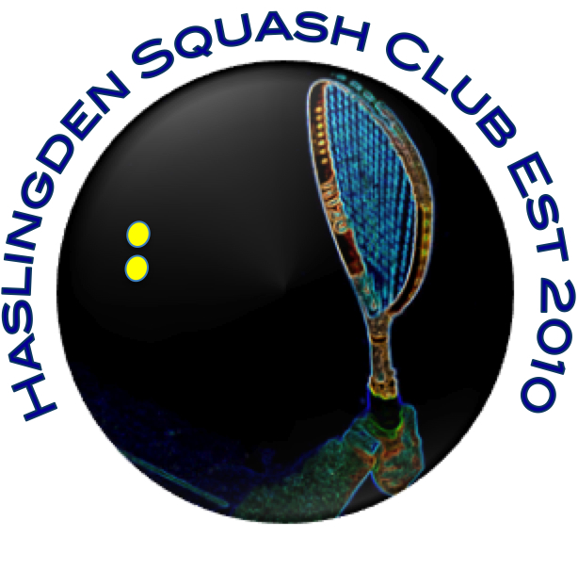

Dear Haslingden Squash Club Members :
It is the time of Christmas cheer and therefore a good time to thank you all for your participation in our club this year, whether that be in the box league/ ladder / teams / competitions or just your vocal and moral support, we hope you have all enjoyed the year and will continue to be a positive influence in 2019.
It also gives us the chance to let you know of a proposed change to the makeup of the box league/ ladder, which we believe will be of benefit to us all, encourage the ongoing participation of the game for all and in the process help to strengthen our club over the longer term.
As you may be aware several years ago, we established a Junior section to Hasi Squash who play on a Saturday morning. The club has now grown to in excess of 40 juniors and if you were fortunate enough to visit the Christmas party last week you would have been amazed at the strength of the junior section, all fresh faced with few of the bad habits (or indeed bad language) displayed by some of our more senior members.
The growth of this section has been achieved by the dedication and hard work of all those that have been involved over the years, and it should be recognised, as happens with all of us, they are getting older (both the juniors and their coaches ).
Sadly, there is limited opportunity for the more accomplished of the juniors to continue their progression in the game (although this is currently being addressed with a Junior team that will play in the new North West Counties junior league), so it is therefore proposed that we open up the senior box league/ ladder to juniors allowing them to get exposure to playing adult squash.

Of course, this is a major change and it important that you as a member are comfortable with this. In order that we can ensure a smooth transition and understanding from the juniors of the ethics within Haslingden Squash Club and the manner in which the game should be played.
In conjunction with the committee of Hasi Juniors, it is proposed that a junior will only be allowed into the box league / ladder for competitive squash once they have proved themselves in terms of ability and temperament to their coaches and other members of the club, this will be by either playing in the teams on a Thursday night or a series of friendlies with other adults and having reached a suitable level they will be allowed to take part.
Once a junior is in the box league / ladder, all their games will need to be supervised by a parent/ guardian, and behaviour monitored. Whilst we don’t envisage an onslaught of juniors, it is important that as existing members you are comfortable with this.
Will you please forward your thoughts and comments to us (you can email admin@haslingdensquash.org.uk) by 01/01/2019 so that we as your committee are able to accurately gauge your thoughts in this and make a decision that suits all.
Once again, thank you for your support this year and long may it continue
On Behalf of your Committee have a wonderful Christmas and an excellent 2019.

